Welcome to Advanced Pain Medicine Associates. Your appointment is scheduled for:

Date: Check-In Time:

In this packet, you will find all of the patient forms required by Advanced Pain Medicine Associates for your initial appointment. Please complete at home and bring with you to your appointment.
(We may have to reschedule if you have not filled out these forms completely by the time of your appointment.)
**Any missed, rescheduled or canceled appointment with less than 24-hour notice may be charged a fee**
**THE FOLLOWING MUST BE BROUGHT TO YOUR APPOINTMENT**

- Photo ID and insurance cards (MVA and/or Work Comp information if related).
- Any X-Ray, MRI, or CT scan reports and films that you have.
- All medication that you are currently taking for your pain (in their original bottles).
- Any other information that you think is relevant.

**IN REGARDS TO MEDICATION MANAGEMENT, THERE IS NO GUARANTEE THAT YOU WILL BE PRESCRIBED AND/OR
KEPT AT YOUR CURRENT DOSING; IT IS CASE BY CASE AND AT THE PROVIDER'S DISCRETION**

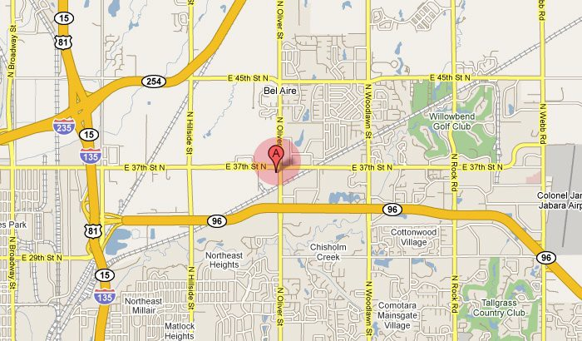

CONTACT INFORMATION:
3715 N. Oliver Wichita, KS 67220

Phone: (316) 942-4519 opt. 4
Fax: (316) 942-4655

From I-35 North/South – Exit off I-35 at exit 53 toward KS-96/WICHITA (Turnpike Toll). Merge onto KS-96 W toward HUTCHINSON. Take the OLIVER exit. Turn RIGHT onto N OLIVER ST. Proceed ¼ mile to facility on left. Advanced Pain Medicine Associates is located at the corner of Oliver and 37th street.

From 135 South – Merge onto KS-96 E via EXIT 10A. Take the OLIVER exit. Turn LEFT onto N OLIVER ST. Proceed ¼ mile to facility on left. Advanced Pain Medicine Associates is located at the corner of Oliver and 37th street.

From 135 North – Merge onto KS-96 E via EXIT 10. Take the OLIVER exit. Turn LEFT onto N OLIVER ST. Proceed ¼ mile to facility on left. Advanced Pain Medicine Associates is located at the corner of Oliver and 37th street.

From 235 South – Merge onto I-135 S/US-81 S/KS-15 S/KS-96 E via EXIT 16A. Continue .8 Miles and Merge onto KS-96 E via EXIT 10. Take the OLIVER exit. Turn LEFT onto N OLIVER ST. Proceed ¼ mile to facility on left. Advanced Pain Medicine Associates is located at the corner of Oliver and 37th street.

ADVANCED PAIN MEDICINE ASSOCIATES
**Providing Hope for Pain Sufferers**
3715 N. Oliver, Wichita, KS 67220 Tel. 316.942.4519 Fax 316-942.4655
JON C. PARKS M.D. GEORGE G. FLUTER M.D.
Rita Simpson P.A Amanda Ewertz APRN Kim Clothier P.A. Christine Reynolds APRN

NEW PATIENT EVALUATION

Today’s Date:_______________ Patient’s Full Name:________________________________________________
Preferred Language:__________________________ Social Security Number:__________________________
Date of Birth:___________ Age:_____ Sex:_____ Married:___ Single:___ Divorced:___ Widowed:___
Ethnicity: Hispanic or Latino____ Not Hispanic or Latino____ Decline to Specify_____
Race: White____ African American____ Asian____ American Indian____ Decline to Specify____
Employment Status: Currently Employed____ Retired____ Disabled____ Unemployed____

CURRENT MEDICATIONS:
______________________________ ______________________________ ______________________________
______________________________ ______________________________ ______________________________
______________________________ ______________________________ ______________________________
______________________________ ______________________________ ______________________________
______________________________ ______________________________ ______________________________
______________________________ ______________________________ ______________________________
______________________________ ______________________________ ______________________________
______________________________ ______________________________ ______________________________

ALLERGIES: REACTION:
Latex ___ ___________________________________________________________
Iodine ___ ___________________________________________________________
Contrast Dye ___ ___________________________________________________________
Shellfish ___ ___________________________________________________________
Penicillin ___ ___________________________________________________________
Sulfa Drugs ___ ___________________________________________________________
___________________________ ___________________________________________________________
___________________________ ___________________________________________________________
___________________________ ___________________________________________________________

PERSONAL & FAMILY MEDICAL HISTORY (check all that apply):

You Family Family Relation
Heart Attack _______ _______ _____________________
Chest Pain _______ _______ _____________________
Heart Murmur _______ _______ _____________________
Heart Palpitations _______ _______ _____________________
High Cholesterol _______ _______ _____________________
Congestive Heart Failure _______ _______ _____________________
High Blood Pressure _______ _______ _____________________
Low Blood Pressure _______ _______ _____________________
Blood Clots _______ _______ _____________________
Heart Disease _______ _______ _____________________
Asthma _______ _______ _____________________
Emphysema _______ _______ _____________________
Bronchitis _______ _______ _____________________
Tuberculosis _______ _______ _____________________
Pleurisy _______ _______ _____________________
Pneumonia _______ _______ _____________________
COPD _______ _______ _____________________
Long-Term Oxygen Therapy _______ _______ _____________________
Sleep Apnea _______ _______ _____________________
CPAP Ventilation _______ _______ _____________________
Kidney Disease _______ _______ _____________________
Dialysis _______ _______ _____________________
Cirrhosis _______ _______ _____________________
Hepatitis _______ _______ _____________________
Ulcers _______ _______ _____________________
Irritable Bowel Syndrome _______ _______ _____________________
GERD _______ _______ _____________________
Crohn’s Disease _______ _______ _____________________
Bowel Obstruction _______ _______ _____________________
Hypothyroidism _______ _______ _____________________
Hyperthyroidism _______ _______ _____________________
Stroke _______ _______ _____________________
Epilepsy/Seizures _______ _______ _____________________
Diabetes Type 1 _______ _______ _____________________
Diabetes Type 2 _______ _______ _____________________

PERSONAL & FAMILY MEDICAL HISTORY (continued):

You Family Family Relation
Cancer:______________ _______ _______ _____________________
Leukemia _______ _______ _____________________
Scarlet Fever _______ _______ _____________________
Rheumatic Fever _______ _______ _____________________
Arthritis _______ _______ _____________________
Rheumatoid Arthritis _______ _______ _____________________
HIV/AIDS _______ _______ _____________________
Fibromyalgia _______ _______ _____________________
Gout _______ _______ _____________________
Lupus _______ _______ _____________________
MRSA _______ _______ _____________________
Depression _______ _______ _____________________
Anxiety _______ _______ _____________________
Suicide/Attempts _______ _______ _____________________
Alcoholism _______ _______ _____________________
Illicit Drug Use _______ _______ _____________________
Prescription Drug Use _______ _______ _____________________
Psychiatric Treatment _______ _______ _____________________
(out-patient)
Psychiatric Treatment _______ _______ _____________________
(in-patient)

PAST SURGICAL HISTORY:

Orthopedic:
Hip YR/MD/TYPE:__________________________________________________
Knee YR/MD/TYPE:__________________________________________________
Joint YR/MD/TYPE:__________________________________________________
Spine:
Cervical YR/MD/TYPE:_________________________________________ Hardware: (Y/N)
Thoracic YR/MD/TYPE:_________________________________________ Hardware: (Y/N)
Lumbar YR/MD/TYPE:_________________________________________ Hardware: (Y/N)

Cardiovascular:
Valve Replacement YR/MD:__________________________________________________
Catheterization YR/MD:__________________________________________________
Pacemaker YR/MD:__________________________________________________
Stent Placement YR/MD:__________________________________________________

PAST SURGICAL HISTORY (continued):

General:
Appendectomy YR/MD:__________________________________________________
Gallbladder YR/MD:__________________________________________________
Hernia YR/MD:__________________________________________________
Upper/Lower EGD YR/MD:__________________________________________________
Colonoscopy YR/MD:__________________________________________________
Gastric Bypass YR/MD:__________________________________________________
Hemorrhoidectomy YR/MD:__________________________________________________
Lung Surgery YR/MD:__________________________________________________
Tonsillectomy YR/MD:__________________________________________________
Adenoidectomy YR/MD:__________________________________________________
Thyroid YR/MD:__________________________________________________
Kidney Surgery YR/MD:__________________________________________________
Lithotripsy YR/MD:__________________________________________________
Partial Colectomy YR/MD:__________________________________________________
Exploratory Laparoscopy YR/MD:__________________________________________________
Other Implanted Devices: YR/MD:__________________________________________________

Head:
Sinus YR/MD/TYPE:__________________________________________________
Eye YR/MD/TYPE:__________________________________________________
Oral YR/MD/TYPE:__________________________________________________
Nose YR/MD/TYPE:__________________________________________________
Ear YR/MD/TYPE:__________________________________________________

Reproductive:
Tubal Ligation YR/MD:__________________________________________________
C-Section YR/MD:__________________________________________________
D&C YR/MD:__________________________________________________
Mastectomy YR/MD:__________________________________________________
Hysterectomy YR/MD:__________________________________________________
Oophorectomy YR/MD:__________________________________________________
Vasectomy YR/MD:__________________________________________________
Prostate YR/MD:__________________________________________________

SOCIAL HISTORY:

Are you right or left-handed?____________ With whom do you currently reside?___________________
Are you currently able to take care of yourself? Yes ___ No ___
If no, please give the name and phone number of your caregiver:____________________________________

Are you presently involved in a lawsuit related to your pain issue: Yes ___ No ___
If yes, please list your attorney’s name and phone number:_________________________________________
If Workers’ Compensation related, please list the employer:_________________________________________

Please select your highest education level: GED ___ High School Diploma ___ Some College ___
Associate’s Degree ___ Bachelor’s Degree ___ Master’s Degree ___ Doctorate ___

SUBSTANCE USE:
Never Seldom Socially Monthly Weekly Daily
Beer _______ _______ _______ _______ _______ _______
Wine _______ _______ _______ _______ _______ _______
Hard Liquor _______ _______ _______ _______ _______ _______
Caffeine _______ _______ _______ _______ _______ _______
Illicit Substances _______ _______ _______ _______ _______ _______
Marijuana _______ _______ _______ _______ _______ _______

Do you currently smoke cigarettes or use tobacco in any form? Yes ___ No ___
If no, have you ever in the past? Yes ___ No ___
How many packs do/did you smoke or use per day?__________ How many years?_________________

PREVIOUS THERAPIES (check all that apply):

Physical Therapy YR/Duration:_________________________ Improvement (y/n):______
Chiropractic Care YR/Duration:_________________________ Improvement (y/n):______
Water Therapy YR/Duration:_________________________ Improvement (y/n):______
Anti-inflammatories YR/Duration:_________________________ Improvement (y/n):______
Opioid Medications YR/Duration:_________________________ Improvement (y/n):______
Epidural Steroid Injections YR/Duration:_________________________ Improvement (y/n):______
TENS Unit YR/Duration:_________________________ Improvement (y/n):______
Lyrica/Gabapentin/Topamax YR/Duration:_________________________ Improvement (y/n):______
Muscle Relaxers YR/Duration:_________________________ Improvement (y/n):______
Heat Therapy YR/Duration:_________________________ Improvement (y/n):______
Ice Therapy YR/Duration:_________________________ Improvement (y/n):______
Acupuncture YR/Duration:_________________________ Improvement (y/n):______
Spinal Cord Stimulator YR Implanted:_________________________ Improvement (y/n):______

PREVIOUS TESTING/STUDIES (check all that apply):

X-ray ___ YR/Facility Name:_________________________________________
CT ___ YR/Facility Name:_________________________________________
MRI ___ YR/Facility Name:_________________________________________
NCV/EMG ___ YR/Facility Name:_________________________________________

FUNCTIONAL LIMITATIONS/PAIN HISTORY/HPI (circle all that apply):

Activities avoided due to pain:
Work Exercise
Physical Labor Driving
Self-care Intimacy
Activities of Daily Living

How often do you experience pain:
Constantly (100%)
Frequently (75% of the time)
Intermittently (50% of the time)
Occasionally (25% of the time)

Indicate any of the following that describes your usual pain quality:
Burning Shooting Pressure
Throbbing Sharp Numbness
Dull/ache Cramping Tingling

Time of day your pain is worse:
Worse in the morning
Worse in the evening
Worse when trying to sleep
No pattern

Indicate your usual level of pain:
Mild Very Severe
Uncomfortable Unbearable
Distressing

How often do you lie down during the day due to pain:
Never Constantly
Seldom Often
Sometimes

FUNTIONAL LIMITATIONS/PAIN HISTORY (continued:)

What makes your pain worse:
Lying Down Bending/Twisting
Standing Coughing/Sneezing
Sitting Urination
Walking Bowel Movement
Exercise Heat
Medications Ice

What makes your pain better:
Lying Down Bending/Twisting
Standing Coughing/Sneezing
Sitting Urination
Walking Bowel Movement
Exercise Heat
Medications Ice

Does your pain stop when you quit the above activities:
Always
Sometimes
Never

Circle your daily level of pain you experience on average using a scale of 0 to 10. “0” being no pain
and “10” being the worst pain you have ever experienced:

No Pain - 0 1 2 3 4 5 6 7 8 9 10 - Worst Pain

REVIEW OF SYSTEMS (circle all that apply):

Constitutional: Head:
Weight Changes Headache
Fever Migraine
Fatigue Sinus Pain
Recent Falls Facial Pain
Chills
Night Sweats
Recent Infection

Otolaryngeal: Pulmonary:
Mouth Sores Shortness of Breath
Difficulty Swallowing Difficulty Breathing
Dentures Sleep Apnea
Difficulty Chewing Chronic Cough
Wheezing

Cardiovascular: Gastrointestinal:
Chest Pain Loss of Appetite
Palpitations Recent Weight Loss
Nausea
Vomiting
Genitourinary: Diarrhea
Dysuria Constipation
Hematuria Heartburn
Genital Lesions
Increased Urinary Frequency
Loss of Bowel/Bladder Control

Hematological: Endocrine:
Easy Bleeding Excessive Sweating
Easy Bruising Tendency Excessive Thirst
Change in Libido

Musculoskeletal: Skin:
Localized Joint Pain Pruritis
Localized Joint Stiffness Skin Lesions
Muscle Aches Rashes

Neurological: Psychological:
Vertigo Sleep Disturbances
Decreased Concentration Anxiety
Memory Lapse or Loss Depression
Fainting

PHYSICAL EXAM:

- Using the symbols below, indicate on the diagram where you have pain.

XXX - Shooting/Stabbing Pain ******* - Achy Pain
//// - Numbness 00000 - Pins & Needles
++++ - Burning Pain ##### - Other Pain

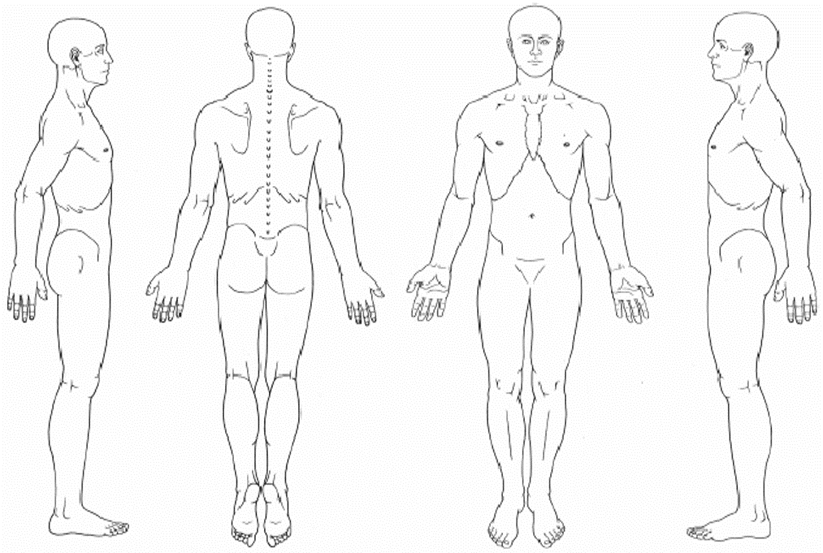

NOTES:_______________________________________________________________________________________
_______________________________________________________________________________________________
_______________________________________________________________________________________________
_______________________________________________________________________________________________
_______________________________________________________________________________________________
_______________________________________________________________________________________________
_______________________________________________________________________________________________
_______________________________________________________________________________________________
_______________________________________________________________________________________________
_______________________________________________________________________________________________
_______________________________________________________________________________________________
_______________________________________________________________________________________________

SOAPP® Version 1.0-14Q

Name: _ _ _ _ _ _ _ _ _ _ _Date: _

The following are some questions given to all patients at the Pain Management Center who
are on or being considered for opioids for their pain. Please answer each question as honestly as possible. This information is for our records and will remain confidential. Your answers alone will not determine your treatment. Thank you.

Please answer the questions below using the following scale:

0 = Never, 1 = Seldom, 2 = Sometimes, 3 = Often, 4 = Very Often

1. How often do you have mood swings? | 0 | 1 | 2 | 3 | 4
2. How often do you smoke a cigarette within an hour after
you wake up? | 0 | 1 | 2 | 3 | 4
3. How often have any of your family members, including parents
and grandparents, had a problem with alcohol or drugs? | 0 | 1 | 2 | 3 | 4
4. How often have any of your close friends had a problem with
alcohol or drugs? | 0 | 1 | 2 | 3 | 4
5. How often have others suggested that you have a drug or
alcohol problem? | 0 | 1 | 2 | 3 | 4
6. How often have you attended an AA or NA meeting? | 0 | 1 | 2 | 3 | 4
7. How often have you taken medication other than the way that it was prescribed? | 0 | 1 | 2 | 3 | 4
8. How often have you been treated for an alcohol or drug problem? | 0 | 1 | 2 | 3 | 4
9. How often have your medications been lost or stolen? | 0 | 1 | 2 | 3 | 4
10. How often have others expressed concern over your medication use? | 0 | 1 | 2 | 3 | 4

©2008 Inflexxion, Inc. Permission granted solely for use in published format by individual practitioners in clinical practice. No other uses or alterations are authorized or permitted by copyright holder. Permissions questions: PainEDU@inflexxion.com. The SOAPP® was developed with a grant from the National Institutes of Health and an educational grant from Endo Pharmaceuticals.

0 = Never, 1 = Seldom, 2 = Sometimes, 3 = Often, 4 = Very Often

11. How often have you felt a craving for medication? | 0 | 1 | 2 | 3 | 4
12. How often have you been asked to give a urine screen for substance abuse? | 0 | 1 | 2 | 3 | 4
13. How often have you used illegal drugs (for example, marijuana, cocaine, etc.) in the past five years? | 0 | 1 | 2 | 3 | 4
14. How often, in your lifetime, have you had legal problems or been arrested? | 0 | 1 | 2 | 3 | 4

Please include any additional information you wish about the above answers. Thank you.

©2008 Inflexxion, Inc. Permission granted solely for use in published format by individual practitioners in clinical practice. No other uses or alterations are authorized or permitted by copyright holder. Permissions questions: PainEDU@inflexxion.com. The SOAPP® was developed with a grant from the National Institutes of Health and an educational grant from Endo Pharmaceuticals.

